**ND ImageJ plugin for image analysis of porous materials: User Manual**

*Introduction*

The ND plugin was written in Java, using the ImageJ built-in Java compiler. The main usage of the ND plugin is to analyze the size and average spacing of particles/pores/tubules located randomly in a sample. The plugin uses an image of the sample as input and outputs a result table listing the average distance of each particle from its neighbors, nearest neighbor distance, and the average wall thickness of its neighbors. The number of neighbors to be accounted for in calculating the averages is set by the user.

*Installation*

To install the plugin, ImageJ must be first installed. ImageJ can be downloaded from http://rsbweb.nih.gov/ij. Variants like Fiji (http://fiji.sc/) may also be used. For detailed instructions on how to use different features of ImageJ, interested readers can refer to <http://rsbweb.nih.gov/ij/docs/user-guide-A4booklet.pdf>.

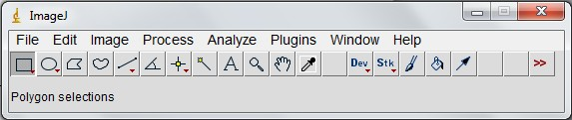

Fig. 1: Main window of ImageJ program

ND\_.java or ND\_.class file (<https://github.com/sedmorteza/ND/blob/master/ND_.java>) should be downloaded to the plugins folder of the ImageJ installation.

*Running the plugin*

The ND\_.java file should be compiled for the first time using “Plugins/Compile and Run ….”.

On restarting ImageJ, the plugin will appear under the menu Plugins. An image needs to be opened (File -> Open…) prior to running the plugin. Otherwise, “There are no images open” message (Fig. 2) will be displayed prompting the user to open an image for analysis. The ND plugin essentially relies on the built-in “Analyze Particle” plugin to populate the Results table and uses its values to calculate the average distance/wall thickness between neighboring particles. Therefore, the built-in “Analyze Particle” plugin under “Analyze->Analyze Particles” should be run before running the ND plugin. A detailed description on how to use “Analyze Particle” built-in plugin is provided at <http://rsb.info.nih.gov/ij/docs/guide/146-30.html>. To make sure that the “Results” table populates the required values that are fed into the ND plugin, “Centroid” and “Fit ellipse” should be check marked under “Analyze->Set measurements” prior to running the “Analyze Particles” plugin and the ND plugin. The user will be notified if any of the above conditions are not met upon running the ND plugin (Fig. 3- Fig. 5).

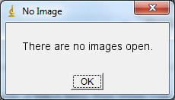

Fig. 2

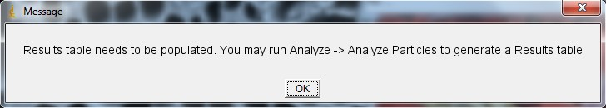

Fig. 3

*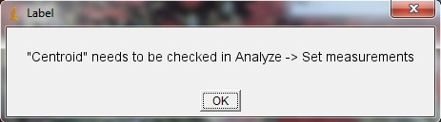*

Fig. 4

*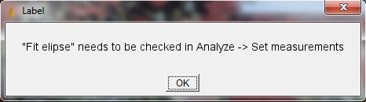*

Fig. 5

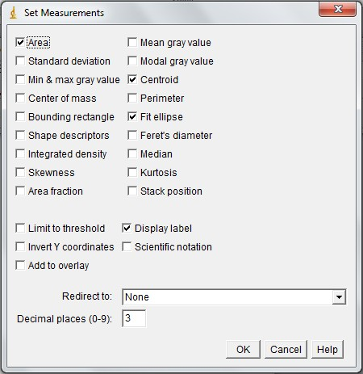

Fig. 6: Set Measurement window listed under “Analyze” from the main window. Centroid and Fit ellipse must be check marked.

*Example of Use*

*Measurement of tubule/fiber diameter and their spacing in tubular scaffolds or fiber reinforced composites*

The main usage of the ND plugin is to analyze the size and spacing of particles/pores/tubules located randomly in a sample. While the size of particles can be estimated using the built-in “Analyze Particle” plugin in ImageJ, the spacing between the features cannot be estimated. Fig. 7 shows an example of a tubular scaffold used in tissue engineering, which can be analyzed using ND plugin. ND provides this ability for the user to calculate the spacing between each particle/pore and its nth closest neighbors with n being the coordination number of interest (Fig. 9). Additionally, the histogram of the average distances of the closest neighbors provides a quantitative measure of how uniformly the feature of interest is spatially distributed. Initially, preliminary steps need to be taken for the plugin to do its function. These steps are as follows:

1. Open the image (File-> Open)
2. Set the scale (Analyze->Set Scale)
3. Threshold the image to make the feature of interest evident (Image->Adjust Threshold)
4. Run the built-in Analyze Particles ( Analyze->Analyze Particles)
5. Run the ND plugin (Plugins->ND)

The result table which outputs the average distance between tubules, the average wall thickness, and the distance of the closest neighbor distance for each tubule is shown in Fig. 9.

The units of measurements are the same as set when the image is scaled. If no scale is set initially the unit of the measurements will be pixels. Instructions on how to set scale for images can be found at <http://rsbweb.nih.gov/ij/docs/user-guide-A4booklet.pdf>.

C:\Users\Morteza\Downloads\Desktop\tubular p(EMA-co-HEA) scaffold_scale bar.tifC:\Users\Morteza\Downloads\Desktop\tubular p(EMA-co-HEA) scaffold_threshold.tif

C:\Users\Morteza\Downloads\Desktop\Drawing of tubular p(EMA-co-HEA) scaffold_outlined.tif

Fig. 7: Scanning electron micrograph of a tubular scaffold (top left), after being thresholded (top right) and after segmentation using built-in Analyze Particles ImageJ plugin (bottom).

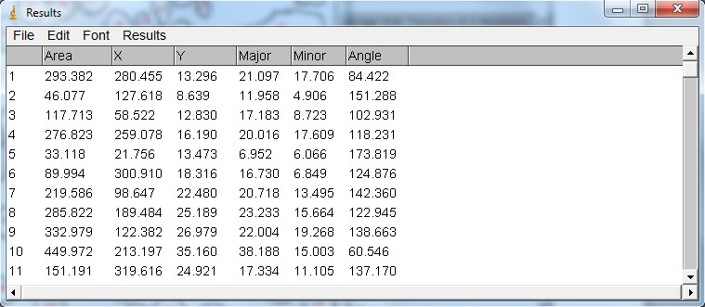

Fig. 8: The Results table associated with Fig. 7

*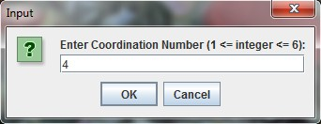*

*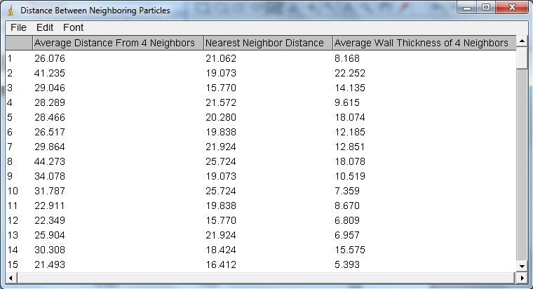*

Fig. 9: ND plugin running. Input window to take the coordination number of interest to the user (top) and the generated result table listing the average distance of each particle from its neighbors, nearest neighbor distance, and the average wall thickness of its neighbors (bottom).

*Algorithm*

In a close packed configuration of particles/fibers having a circular cross section in 2D space there are 6 immediate neighbors surrounding each particle. In randomly packed systems, coordination number depends on the visual perception and can be lower or higher. Estimation of particle spacing of a particle with its neighboring particles is performed as follows:

1. The centroid coordinates of each particle (X,Y) is derived from the result table of the Analyse Particles plugin.
2. A circle is fit on each particle with the center (X,Y) and radius r.
3. The spacing between a pair of particles (d) is calculated as: 

*r1*

*d*

*r2*

.

.

1. The distances of each particle with all the other particles is stored in an array and sorted.
2. Depending on the coordination number of interest, average of the distances is calculated.
3. Results are shown in a new result table, which contain the distance of the closest neighbor to each particle, the average wall thickness, and the average distance of the closest neighbors.